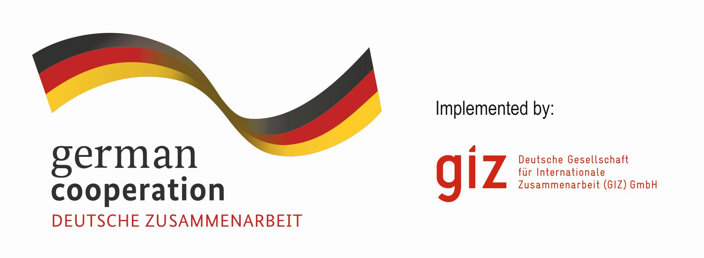

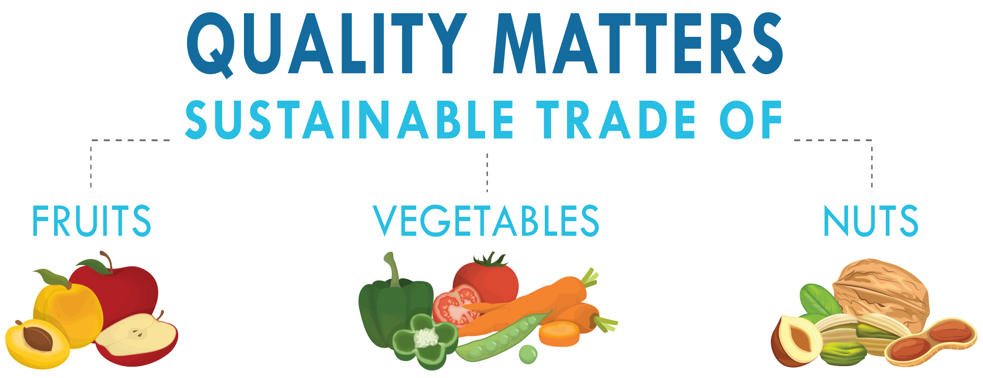

Workshop
Tashkent, Uzbekistan
«Miran hotel»
11 to 13 September 2018

Programme
TUESDAY, 11 SEPTEMBER 2018
9:30 – 10:00 | REGISTRATION
10:00 – 10:35 | OPENING  10:00-10:10 Welcome address – Uzbekistan  10:10-10:20  Introduction Review of activities in Central Asia  UNDP, GIZ  10:20-10:35  Quality, sustainability in international agriculture trade – the what, where, why, who and how - UNECE and its role in improving quality of agricultural produce and preventing food loss  Liliana, ANNOVAZZI-JAKAB, Head Agri Standards Unit, United Nations Economic Commission for Europe, UNECE
10:35 – 11:05 | Sustainable trade in agricultural produce– UNCTAD’s new project for the region  Romain Perez, United Nations Conference for Trade and Development, UNCTAD  Quality production  FAO Office Uzbekistan (tbc)
11:05 – 11:20 | COFFEE BREAK
11:20 – 13:00 | Quality and sustainability for agriculture trade – focus fresh fruit and vegetables, nuts and dried fruit  1. The private sector views  Quality requirements and controls (wholesalers and supermarkets in local and destination markets) - Meeting retail specifications and standards for access to leading trade chains and niche markets (including organic)  Mr. Giuseppe CALCAGNI, Chairman, Scientific Committee, International Nut and Dried Fruit Council Foundation (INC) and President Besana, Italy  Mr. Neville MCHINA, Import / Export Manager, Vitaina, Netherlands  2. The Regulatory Perspective  From international to national: international standards, best practices and experiences in implementing standards at the national level  UNECE expert Turkey
13:00 – 14:00 | LUNCH BREAK
14:00 – 15:15 | Quality and sustainability for agriculture trade – focus fresh fruit and vegetables, nuts and dried fruit  - The Regulatory Perspective  Quality and the use of agricultural quality standards in EU countries  Dr. Kristina MATTSSON, Head of Unit, Swedish Board of Agriculture, Sweden  Getting it right – why checking quality matters and how it can be done: An introduction to setting up quality inspection systems  Dr. Ulrike BICKELMANN, Head of Inspection Service, Bundesanstalt für Landwirtschaft und Ernährung (BLE), Germany  The country perspectives: Case reviews and discussions  Reports from public and private sectors - achievements, concerns, opportunities, cooperation  Kyrgyzstan, Tajikistan, Uzbekistan, etc.
15:15 – 15:30 | COFFEE BREAK
15:30 – 16:00 | Prospects for Central Asia – the commercial side  Markets and developments- nuts and dried fruit industry  Mr. Giuseppe CALCAGNI, Chairman, Scientific Committee, International Nut and Dried Fruit Council Foundation (INC) and President Besana, Italy  Markets and developments- fresh fruit and vegetables  Mr. Neville MCHINA, Import / Export Manager, Vitaina, Netherlands
16:00 – 16:30 | Towards a roadmap for quality  Liliana, ANNOVAZZI-JAKAB, Head Agri Standards Unit, United Nations Economic Commission for Europe, UNECE with UNDP, UNCTAD, GIZ
WEDNESDAY, 12 SEPTEMBER 2018
9:30 – 13:00  With COFFEE BREAK | Product Training / Quality Control and Inspection- 1  (participants will receive intensive training in small groups of max. 20)  TOMATOES, MELONS, DRIED GRAPES, DRIED APRICOTS AND WALNUTS  UNECE Resource persons from Germany, Sweden, Italy, Netherlands, Turkey, UNECE
13:00 – 14:00 | LUNCH BREAK
14:00 – 16:30  With COFFEE BREAK | Product Training / Quality Control and Inspection – 2  (participants will receive and intensive training in small groups of max. 20)  TOMATOES, MELONS, DRIED GRAPES, DRIED APRICOTS AND WALNUTS  UNECE Resource persons from Germany, Sweden, Italy, Netherlands, Turkey, UNECE

THURSDAY, 13 SEPTEMBER 2018
8:30 – 13:30 | STUDY TOUR AND TRAINING  Limited number of participants  Keeping and checking quality:  - Keeping quality along the supply chain  - Sampling methods for fresh fruit and vegetables  - Tests to determine quality of fruits and vegetables
13:30 – 14:30 | LUNCH BREAK
14:30 – 16:00 | Roadmap for Quality – discussions, conclusions and next steps  Moderated by UNECE, UNDP, GIZ with resource persons

